

**UR Viswaanand** (Erasmus student)

COURSE: DATABASES

ASSIGNMENT 7

SQL FUNDAMENTALS

SUBQUERIES

SQL SERVER MANAGEMENT STUDIO

2018

**Theory Part:**

**Subquery :**

* A subquery is that code that can be used to filter the data from the database to reduce the time there are SELECT class, FROM class, WHERE class.
* Also can be used inside a select, insert, update OR delete statements.
* Subquery also called as inner query or a nested query.
* The inner query executes first before it parent query so that the result of an inner query can be passed to the outer query.
* A query immediately enclosed set function is impossible.

Example:

SELECT id, first name

FROM student details(this is table that you wanted)

WHERE first name IN (**'here we can write the name that you need** ');

* By using subquery, structure a complex query into isolated part of data broken of step by step code maintenance.
* Subqueries allow you to use the result of another query in the outer query.

Reference:

<https://www.tutorialspoint.com/sql/sql-sub-queries.htm>

<https://www.w3resource.com/sql/subqueries/understanding-sql-subqueries.php>

<http://www.geeksengine.com/database/subquery/what-is-subquery.php>

**Practical Part:**

1. Find the branch where Ann works. Include at least columns Street and City from Branch table. If you want to include column FirstName from Staff table, you need to use JOIN operation.

|  |
| --- |
| SELECT FirstName,City,Street  FROM Branch JOIN Staff  on staff.BranchId = branch.Id  WHERE FirstName LIKE '%Ann%' |

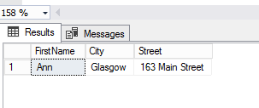

1. List the Staff who work in the branch at ’32 Manse Road’… and only those whose position is ‘Assistant’ in that same branch. Include at least columns FirstName and FamilyName from Staff table. If you want to include column Street information from Branch table, you need to use JOIN operation.

|  |
| --- |
| SELECT Firstname, FamilyName, Position,Street  FROM Branch JOIN Staff  ON Staff.BranchId = Branch.Id  WHERE Street like '%32 Manse Road%' |

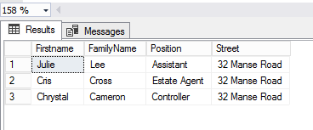

1. Find the owner of the property for rent at address ‘Slippery Lane 16’. Include at least columns FirstName and FamilyName from PrivateOwner table. If you want to include column Street information from PropertyForRent table, you need to use JOIN operation.

|  |
| --- |
| SELECT po.FirstName, po.FamilyName,pr.street  from PrivateOwner po join PropertyForRent pr  on po.Id = pr.PrivateOwnerId  Where pr.street like '%slippery Lane 16%' |

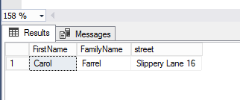

1. List the names of all clients who have viewed a property at 15th of June. Include at least columns FirstName and FamilyName from Client table. If you want to include column ViewDate information from Viewing table, you need to use JOIN operation. Using JOIN needs also keyword DISTINCT.

|  |
| --- |
| SELECT distinct FirstName, FamilyName,  format(w.ViewDate, 'd', 'en-US') as VisitDate  from Client join Viewing as w  on Client.Id = w.ClientId  where w.Viewdate = '2018-06-15' |

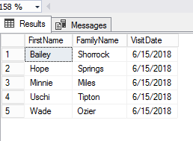

1. List the names of all clients who have viewed a property at 15th of June or at 16th of June. Include at least columns FirstName and FamilyName from Client table. If you want to include column ViewDate information from Viewing table, you need to use JOIN. If you choose to use DATEPART() function (for some personal reason) your query may become a lengthy one. If you choose to use JOIN operation you may need to add DISTINCT keyword.

|  |
| --- |
| SELECT distinct FirstName, FamilyName,  format(w.ViewDate, 'd', 'en-US') as VisitDate  from Client join Viewing as w  on Client.Id = w.ClientId  where w.Viewdate = '2018-06-15'  OR w.ViewDate = '2018-06-16' |

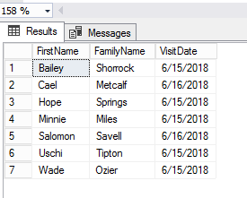

1. List the name of all clients who has viewed a property at 15th of June and who did not give any comments. Include at least columns FirstName and FamilyName from Client table. If you want to include column ViewDate information from Viewing table, you need to use JOIN operation.

|  |
| --- |
| SELECT DISTINCT FirstName, FamilyName,ViewDate  FROM Client, Viewing  WHERE Viewing.ClientId= Client.Id  AND ViewDate = '2018-06-15' AND CommentsGiven IS NULL |

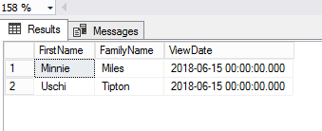

7. Find the name of a staff member who manages property for rent at ‘8 Naval Drive’. Include at least columns FirstName and FamilyName from Staff table. If you want to include column Street information from PropertyForRent table, you need to use JOIN operation.

|  |
| --- |
| SELECT s.FirstName,s.FamilyName, pr.Street  FROM Staff s JOIN PropertyForRent pr  on s.Id = pr.StaffId  Where pr.Street like '%8 Naval Drive%' |

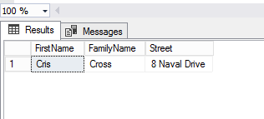

8. Find the names of all clients who have viewed Flats. Include at least columns FirstName and FamilyName from Client table. If you want to include TypeOfProperty information from PropertyForRent table, you need to use JOIN operation.

|  |
| --- |
| SELECT Distinct FirstName,Familyname,TypeOfProperty  From Client join Viewing  ON Client.Id = Viewing.ClientId  Join PropertyForRent  ON Viewing.PropertyForRentId = PropertyForRent.Id  Where PropertyForRent.TypeOfProperty ='Flat' |

